Ian Jablonowski

As a final desperate cry for attention, Al Gore has come up with his own solution to global warming. Rather than wait for citizens to clean their own act up, Gore took matters into his own hands. In late January 2009, Gore managed to lower the average temperature of the Earth by almost 10 degrees through unknown means. Although unsuccessful at fixing our global warming problem, Gore found a temporary solution. This unnatural change was only temporary, but has caused catastrophic changes to the earths precipitation. Gore has stated that his next attempt to fix our global warming problem will be by manually refreezing our polar ice caps.

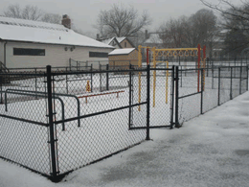

**An ice covered childrens area**Disabled children are no longer able to enjoy their ourdoor playground, thanks Al Gore.

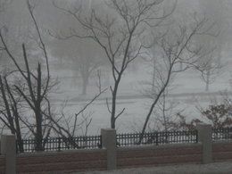  
**A foggy January morning**Al Gores attempt to solve global warming put almost all forms of public transportation to a hault.

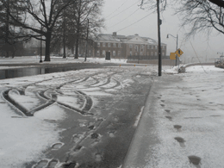

**A desperate attempt to escape the ice**  
A truck’s treadmarks the driver makes an attempt to escape their icy fate. 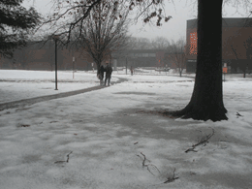

**A determined couple**  
Although classes weren’t canceled, very few students made the attempt to futher their education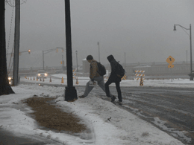

**As the ice clears up**  
A couple students venturing out toward what is only the beginning of the storm

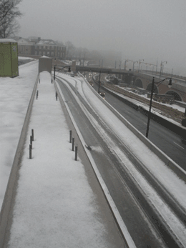

**18 on this treacherous day**Road conditions were the lowest in years, only emergency vehicles were seen on the road.

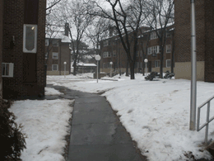

**A frozen walkway**Although it may look friendly, walkway injuries were a common occurrence during Al Gores day of reckoning.

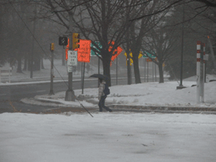

**Some confusion**  
This Rutgers student was unaware of Al Gores plan for the weather today, as this student assumed it was merely just mid day a drizzle.

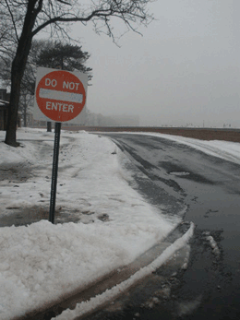  
**Deep Slush**  
Comparing the length of a normal sign and this submerged DO NOT ENTER sign, we can conclude that Al Gore was the cause of the oh so many inches of slush last week.